CPE301 – SPRING 2019

Midterm 1

Student Name: Tyler Gardenhire

Student #: 8000450294

Student Email: gardenhi@unlv.nevada.edu

Primary Github address: [gardenhi@unlv.nevada.edu](mailto:gardenhi@unlv.nevada.edu)

Directory: https://github.com/tylergardenhire/submission_projects.git

Submit the following for all Labs:

1. In the document, for each task submit the modified or included code (only) with highlights and justifications of the modifications. Also, include the comments.
2. Use the previously create a Github repository with a random name (no CPE/301, Lastname, Firstname). Place all labs under the root folder ESD301/DA, sub-folder named LABXX, with one document and one video link file for each lab, place modified asm/c files named as LabXX-TYY.asm/c.
3. If multiple asm/c files or other libraries are used, create a folder LabXX-TYY and place these files inside the folder.
4. The folder should have a) Word document (see template), b) source code file(s) and other include files, c) text file with youtube video links (see template).

1. **COMPONENTS LIST AND CONNECTION BLOCK DIAGRAM w/ PINS**

Atmel Studio 7 w/ AVR assembly, Atmega328p board, FTDI chip, and ESP module used.

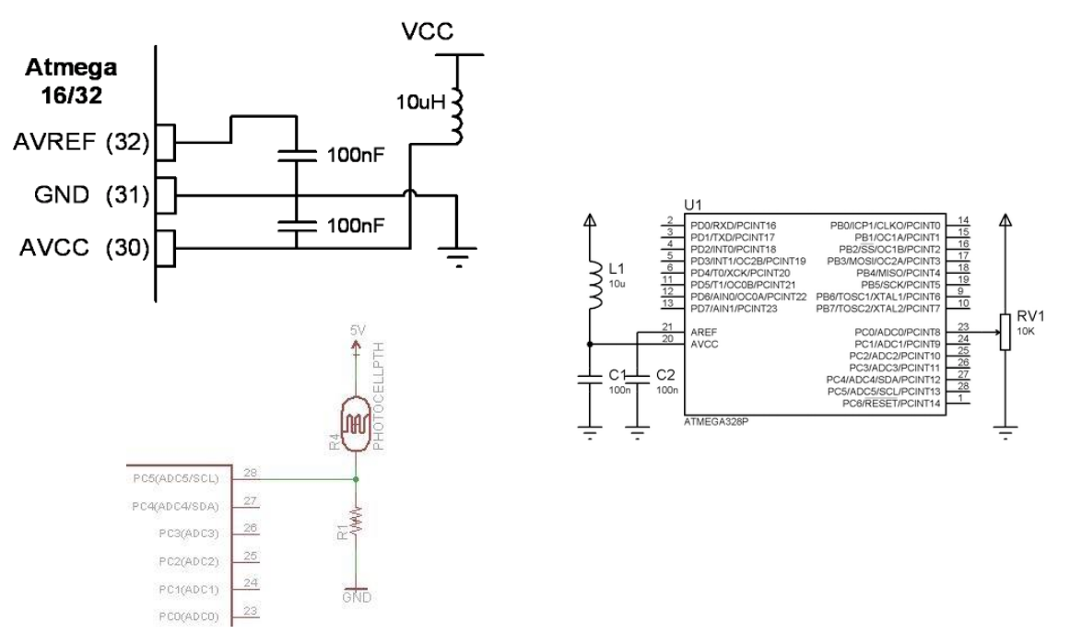

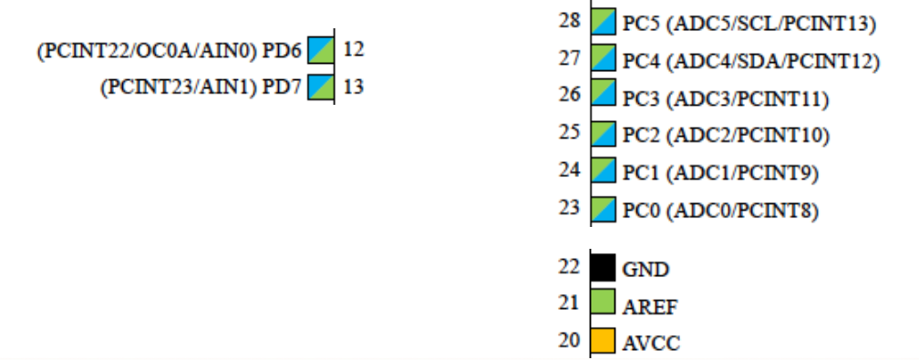

1. **INITIAL/MODIFIED/DEVELOPED CODE OF TASK 1/A**

/*

* midterm1.c

*

* Created: 4/7/2019 12:36:13 PM

* Author : Tyler

*/

#include <avr/io.h>

#include <avr/interrupt.h>

#include <util/delay.h>

#include <stdlib.h>

#include <stdint.h>

#define *F_CPU* 16000000UL

#define BAUD 115200

#define FOSC 16000000

#define BAUDEQ FOSC/8/BAUD -1

volatile *uint8_t* ADCvalue;

volatile unsigned char ADCtemp[5];

volatile unsigned char CWMODE[] = "AT+CWMODE=3\r\n"; //WiFi mode = 3

volatile unsigned char WIFI[] = "AT+CWJAP=\"gardenhi\", \"BasketballStar23\"\r\n"; //connect to internet

volatile unsigned char ENABLE[] = "AT+CIPMUX=0\r\n"; //connected to 2.4GHz WiFi

volatile unsigned char CIPSTART[] = "AT+CIPSTART=\"TCP\",\"184.106.153.149\",80\r\n"; //tcp

volatile unsigned char CIPSEND[] = "AT+CIPSEND=45\r\n"; //length of data = 45

volatile unsigned char SEND_DATA[] = "GET /update?key=1Q0Z8SVE7A1ONWS1&field1="; //API

volatile unsigned char PAUSE[] = "\r\n\r\n"; //go to left side, skip a line

void ADCinit (void);

void UARTinit (void);

void sendAT (volatile unsigned char c[]);

int main( void )

{

ADCinit(); //initializes ADC values

UARTinit(); //initializes UART values

//calls functions to enable WiFi mode, connects to the specific WiFi

*_delay_ms*(1000);

signal_AT(CWMODE);

*_delay_ms*(1000);

signal_AT(WIFI);

*_delay_ms*(2000);

signal_AT(ENABLE);

while(1) //send values through the cloud until off

{

//calls functions to connect to thingspeak

*_delay_ms*(1000);

signal_AT(CIPSTART); //connects to thingspeak

*_delay_ms*(1000);

signal_AT(CIPSEND); //set length of data

*_delay_ms*(1000);

signal_AT(SEND_DATA);

signal_AT(ADCtemp); //send data

signal_AT(PAUSE); //pause, load data

}

}

void ADCinit (void)

{

ADMUX = (1 << REFS0) | //voltage reference

(1 << ADLAR); //left adjust ADC conversion

//ADC Control and Status Register A, ADC enable, ADC start conversion,

//ADC auto trigger enable, ADC interrupt enable, 128 prescaler

ADCSRA = (1 << ADEN) | (1 << ADSC) | (1 << ADATE) |

(1 << ADIE) | (1 << ADPS2) (1 << ADPS1) (1 << ADPS0);

}

void UARTinit (void)

{

UBRR0H = UBRREQ >> 8; //shifts right to store upper 8 bits

UBRR0L = UBRREQ; //store lower 8 bits

UCSR0A |= (1 << U2X0); //doubles USART transmission speed

UCSR0B |= (1 << TXEN0); //enables USART transmitter

UCSR0C |= (1 << UCSZ01) |

(1 << UCSZ00); // 8-bit size

sei(); // Enable global interrupt

}

ISR(ADC_vect)

{

volatile unsigned int j=0;

char temp[5];

ADCvalue = (ADCH << 1); //shifts the value left to one place

*itoa*(ADCvalue, temp, 10); //converts integers to string

while (j<5) //transfers the temp string

{

ADCtemp[j] = temp[j];

j++;

}

}

void sendAT(volatile unsigned char c[]) {

volatile unsigned int i=0;

volatile unsigned int j=0;

j = 0; //initialize counter

while (c[j] != 0x00) //while not at end of string

j++;

while (i<j) //if UDRE0 = 1, buffer can be written

{

while(!(UCSR0A & (1 << UDRE0)));

UDR0 = c[i];

i++;

}

}

1. **DEVELOPED MODIFIED CODE OF TASK 2/A from TASK 1/A**

N/A

1. **SCHEMATICS**

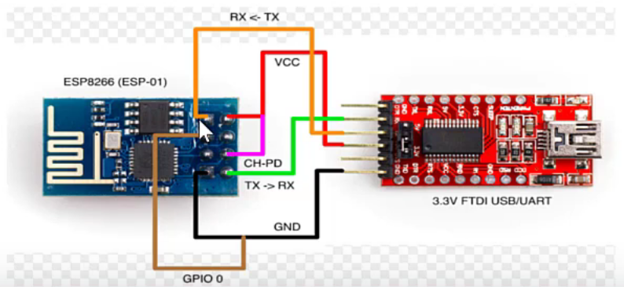

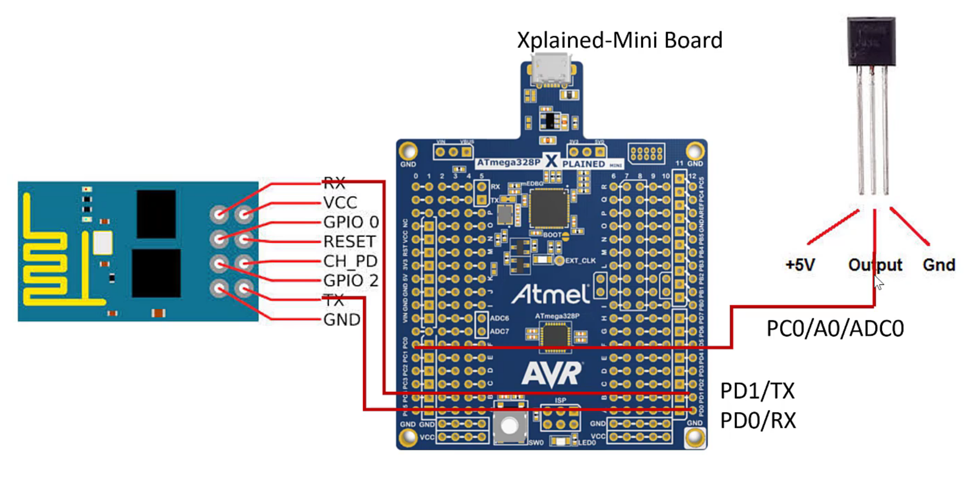

1. **SCREENSHOTS OF EACH TASK OUTPUT (ATMEL STUDIO OUTPUT)**

Task 2:

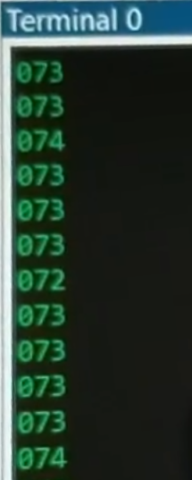

Task 3:

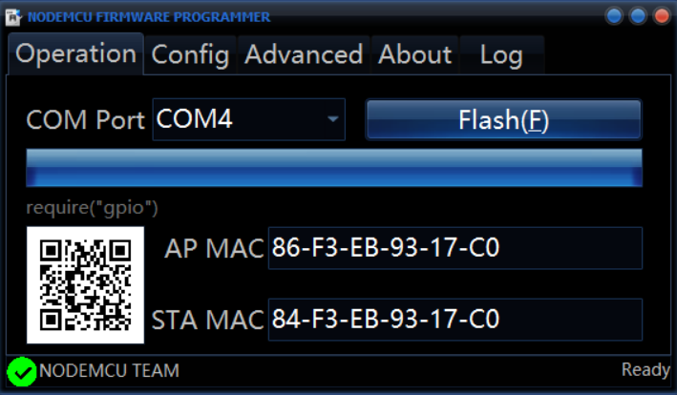

Task 4:

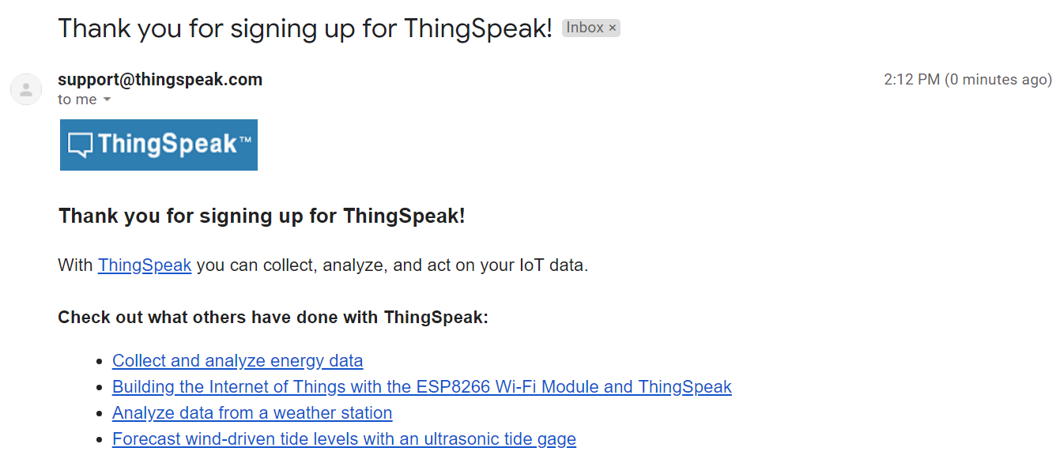

Task 5:

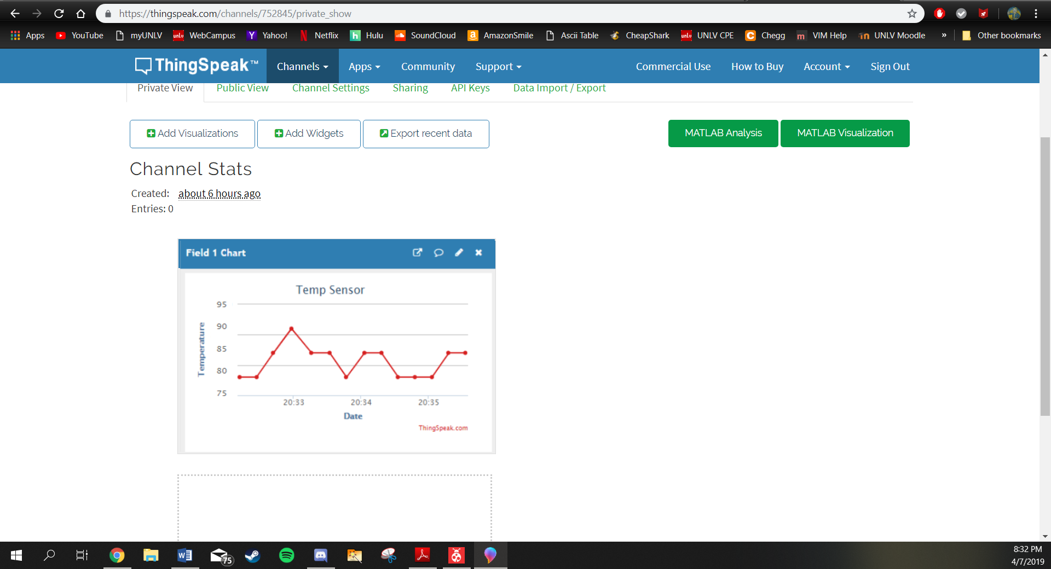

1. **SCREENSHOT OF EACH DEMO (BOARD SETUP)**

Programming mode:

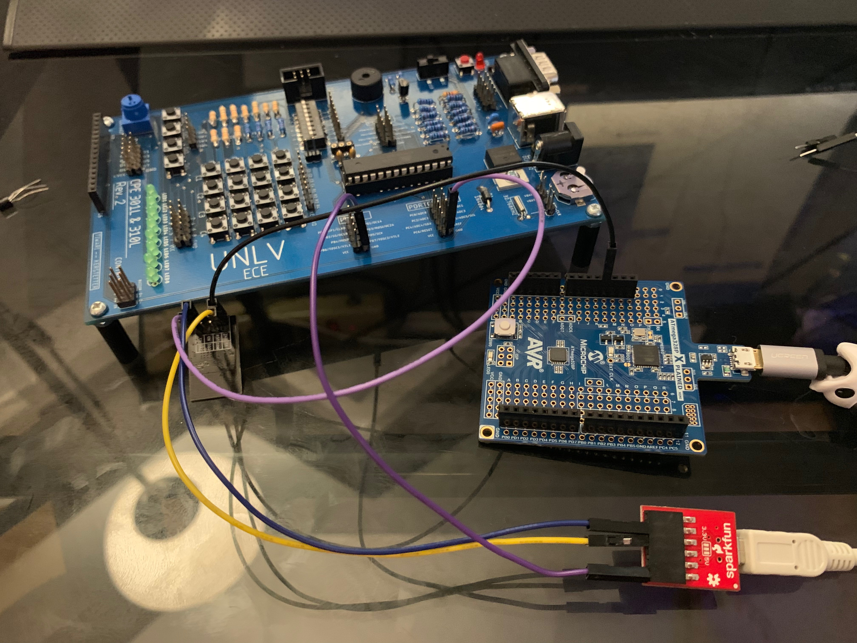

Output Mode:

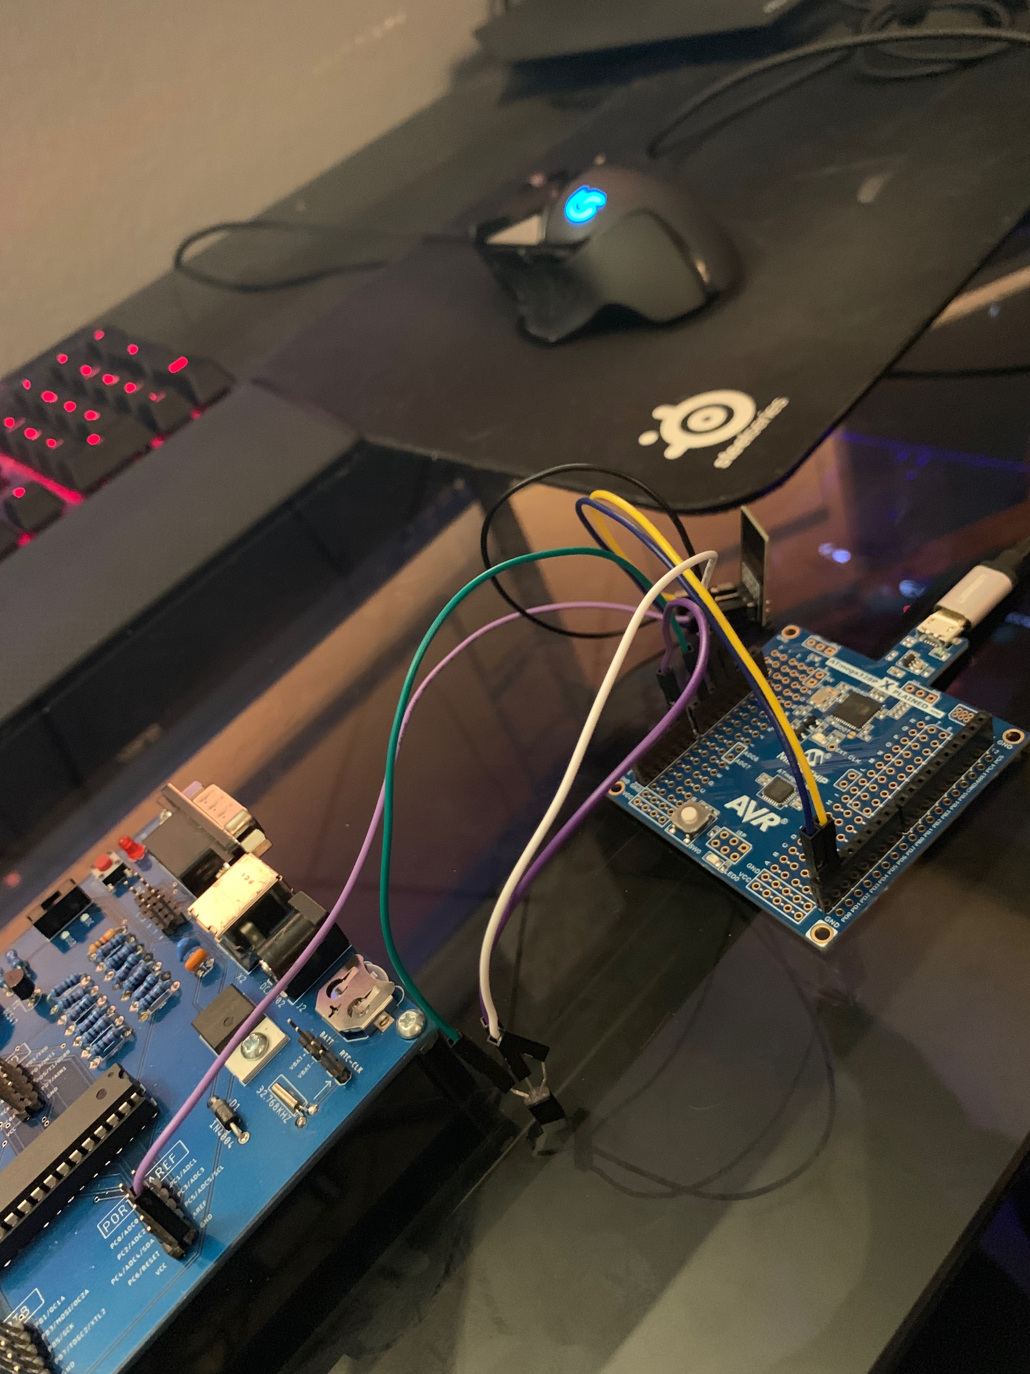

1. **VIDEO LINKS OF EACH DEMO**

<https://youtu.be/84T_1Nl3WU4>

1. **GITHUB LINK OF THIS DA**

https://github.com/tylergardenhire/submission_projects.git

**Student Academic Misconduct Policy**

<http://studentconduct.unlv.edu/misconduct/policy.html>

“This assignment submission is my own, original work”.

TYLER GARDENHIRE